OpenClassrooms full stack developer path
https://openclassrooms.com/en/paths/104-full-stack-developer

HTML head: Information about web pages, like their titles, icons, social sharing images, and descriptions live in an area of your HTML document called the head.
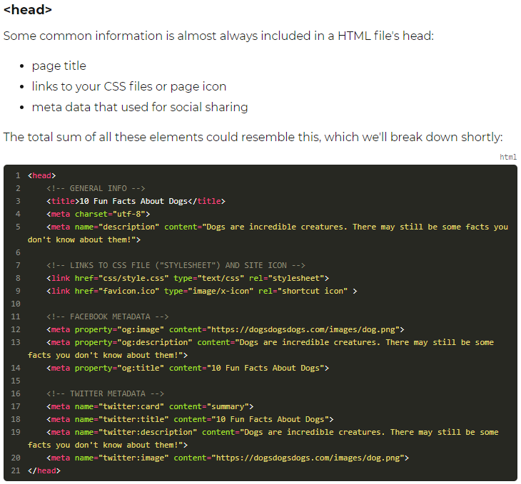

HTML body: will contain all the content: text, images, and anything on the page.

HTML elements (h1,h2,...h6,p,a,ul,ol,li,img,figure,figcaption,br, hr, strong, em, ...)
a = anchor = hyperlink
ul = unordered list
ol = ordered list
li = list items
br = line break (no closing tag)
hr = horizontal rule
HTML structural elements (header, nav, section, article, footer, aside, figure)
HTML general elements: div (block-level) and span (inline) (for anything that is not standardized like the above)

HTML custom classes and ids to distinguish elements (given in element attributes)
Ids is for an element that appears only once

HTML element attributes (info/params needed to create element)

Css = cascading style sheets. It’s the last reference to a html element that will determine its css properties
Css:
Selector {
Property: value;
}
css properties (font-family, color, background-color, font-size, line-height, letter-spacing, word-spacing, font-weight, font-style -e.g. italic-, text-decoration -e.g. Underline-, text-transform -e.g. uppercase, ...)

Css reference to html: element name or .class_name for custom class and #id_name for custom id
Css styles based on status (e.g. links):
a:hover {...} style given to a link when mouse hovers over it. Also :visited and :active

Finding colors: https://htmlcolorcodes.com/color-picker/

Css layout
The border property can be used to set borders
Padding property: space between element and border
Margin property: space between different elements
Width and height properties can be used to set element size
If box-sizing property is set to border-box, size of (element+padding+border) is set
If box-sizing property is set to content-box, size of element is set (default)
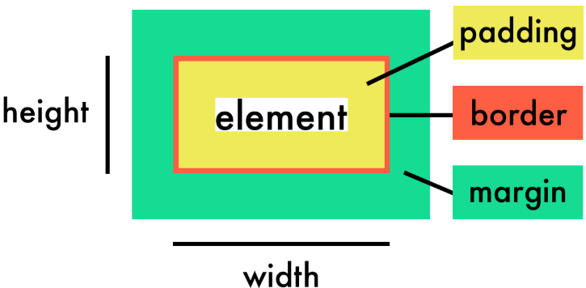

Media queries allow the loading of various CSS styles based on certain settings.
You create a media query with the @media directive followed by the screen type and one or more conditions (such as the maximum screen width). The following CSS style will be enabled only if the conditions are met.

